4 Techniques for Dissociation of Human Cancer Cells
Luke Doiron on Jun 2, 2015 3:48:40 PM
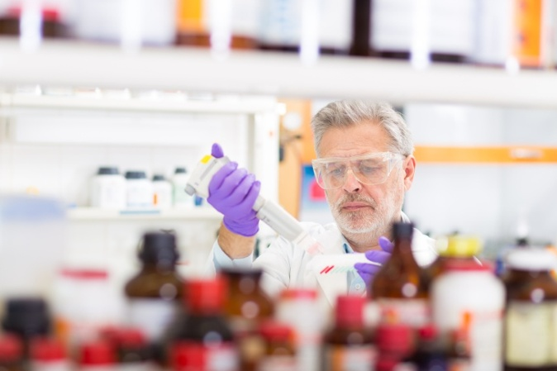
Over the years, a variety of protocols and methods have been developed for dissociation of different types of human cancer cells. One reason for the rise of different protocols was a 1989 breast cancer study that found a link between the types of cancer cellular subpopulations found in dissociated tumor samples and the method of dissociation used.
Today, the most common techniques for cancer cell dissociation are enzymatic and mechanical, or some combination of the two. Within those two broad categories are a wide range of specific techniques and protocols, which vary depending upon the cellular targets and tumor type. In general mechanical dissociation entails mincing, cutting and sieving of tumor tissue into smaller fragments. Enzymatic dissociation (sometimes called digestion) uses a variety of enzymes, for example collagenase, trypsin, or pronase.

Here are four interesting papers detailing techniques used for the dissociation of various human cancer cells:

#1. Human Glioblastoma Multiforme (GBM) tumor cells
Stem-like cells have been isolated from many different types of tumors, including glioblastoma multiforme, an aggressive brain tumor with a pejorative prognosis. In this study, authors used the neurosphere assay culture method to identify and isolate tumor-initiating cell populations in GBM tumors. The resected tumor is placed in a tube containing neural stem cell (NSC) based medium supplemented with antibiotics. To dissociate, it is then washed and cut into small pieces and minced with a number 10 scalpel blade to render into tiny pieces. This minced tissue is then enzymatically dissociated with trypsin, trypsin inhibitor is added, and tissue pieces are further dissociated by gentle pipetting up and down to obtain a smooth milky single cell suspension.

#2. Melanoma-specific tumor-infiltrating lymphocytes and stem cells
There are a variety of cell types found in melanoma that are useful for tumor biology research. Cancer stem cells (CSCs) seem to be implicated in many melanoma cases, which could explain why this cancer is hard to permanently eradicate. This research built on recent studies showing that inconsistent melanoma CSC results were due in part to the use of too-aggressive proteases during dissociation, most specifically trypsin, which cleaves off ABCB5 and CD44, a key cell surface tumor marker. In this protocol, authors followed standard protocol with a commercially available tumor dissociation kit and mechanical dissociator. They conclude that this method can reliably dissociate melanoma tissue into single-cell suspensions with high viability and yield rates, and importantly, preserved cell surface epitopes.

#3. Optimizing tumor xenograft dissociation for cell surface marker and nutrient transport profiling
Cell markers for tumor cell metabolism are important targets of research, yet are difficult to obtain, in part because dissociation procedures can disrupt surface marker expression and/or detection. This study details a tumor dissociation procedure and a nutrient transporter technology that may assist future research and drug discovery. The authors removed xenograft human breast cancer tumors and mechanically minced them into 2-4mm fragments. They were incubated for a short time with NEDB and then enzymatically dissociated with collagenase III and DNAse I, then purified with Ficoll gradient. The process yielded good cell counts and viability.

#4. Cancer stem cell (CSC) isolation from human hepatoma cell lines
It's postulated that CSCs cause the initiation, progression and recurrence of hepatocellular carcinoma (HCC), the third leading cause of cancer deaths worldwide. CSCs were dissociated from human hepatoma cell lines using trypsin-EDTA and then mechanically dissociated using a pipette. The identification of tumorogenic liver CSCs inthis study could offer new insight into how HCC tumors occur and what therapies might work against such tumors.

